A visit to Freemasons’ Hall – 2nd April 2019
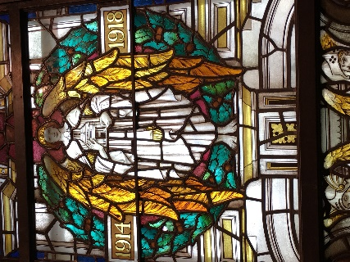
After a very successful previous visit in 2018, a group of 35+/- Consorts and Guests visited this amazing building, completed in 1933, whose original name was the Masonic Peace Memorial Building. The tour was organized for us by Past Master Baker Patrick Wilkins and led by an excellent guide who showed an extensive knowledge of the Masons – past and present and of this Building.
We started in the Museum, well worth a visit in its own right, where he highlighted particularly the size of the chair used for the only Monarch to be Grand Master (George IVth) who was apparently over 30 stone!), Not quite how his portrait alongside the chair showed him.
As we moved through the building we learned of various Films and TV series made in or outside the building Spooks, Poirot, Sherlock Holmes, Victoria…… and that the whole building was paid for by Lodges globally, whether in Cash or in kind. (Total cost then £1.4m, today £80m).
We walked down the Processional Corridor leading to the Grand Temple where the walls are made of Tasmanian Hardwood. Sad to say, it is believed that the provision of this wood was basically responsible for the destruction of the forest in Tasmania with virtually none of this wood now in existence.
It seems one of the highlights for many were the Stained-Glass windows surrounding the Role of Honor for the Masons who died in the first world war. (8000 plus)

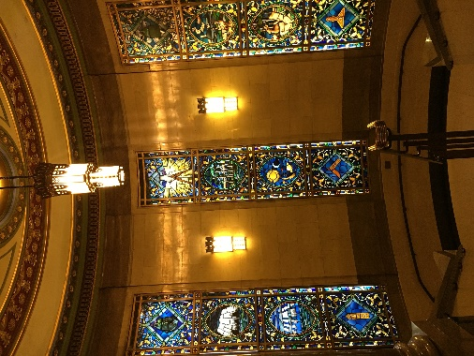

Stunning colors and beautiful designs (no one knows who designed them).
We then moved to the doors leading into the Grand Temple, these are solid brass and weigh 1.5 tons each but can be opened with a very gentle push.
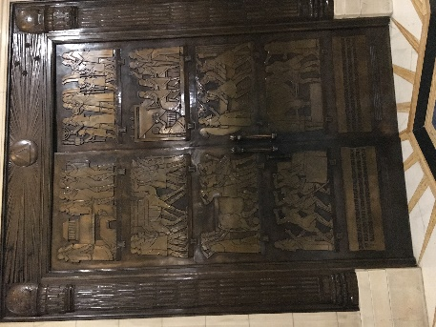
The Grand Temple itself is a separate building within the building itself and is surrounded by a courtyard. It holds over 8000 people with a highly decorated ceiling of mosaic which took 2 years to complete.
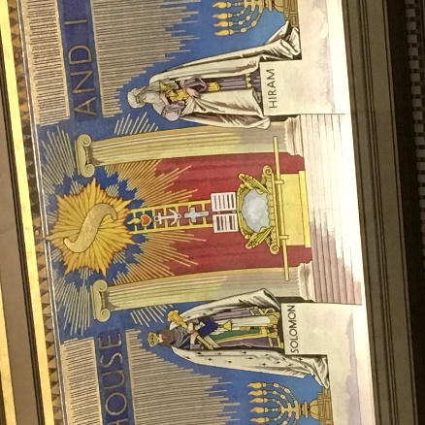
Whilst we were here the guide encouraged a range of questions, which in the main were concerning the supposed secrecy of the Masons and the involvement of women (they have their own separate organization). With regard to secrecy, it was explained that when the Masons were founded in 1717 the building of Cathedrals was in great decline so when looking for work Masons, whether in the UK or Europe, needed a way to prove to potential employers that they were real Masons and had reached a certain level of craft, so would be paid accordingly. Thus, a series of symbols, words and a handshake were developed. Also, regrettably in the Second World War – the fear of a German invasion created again a need for secrecy.
As we left Patrick Wilkins took us to see one of the smaller temples “Horus” (there are 19 in total used by various Lodges) really beautiful.
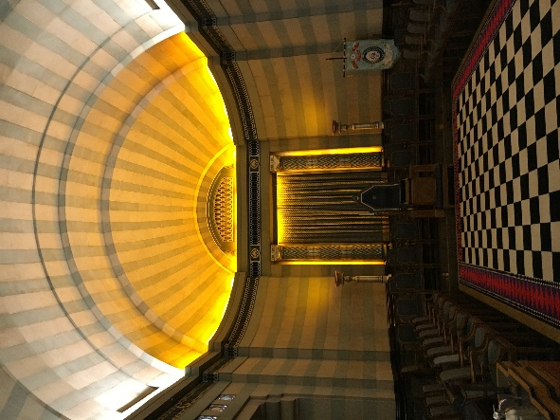
We then decamped to the Prince of Wales for an enjoyable lunch learning even more about the Masons from Patrick. A fascinating and interesting day.

